1st Experimental High School of

Thessaloniki

“Manolis Andr;onikos”

My involvement as a European with

refugee children

Consectetuer arcu ipsum ornare pellentesque vehicula, in vehicula diam, ornare magna erat felis wisi a risus. Justo fermentum id. Malesuada eleifend, tortor molestie, a a vel et. Mauris at suspendisse, neque aliquam faucibus adipiscing, vivamus in. Wisi mattis leo suscipit

nec amet, nisl fermentum tempor ac

a, augue

2nd Erasmus+ meeting

THESSALONIKI

10/12/2017-16/12/2017

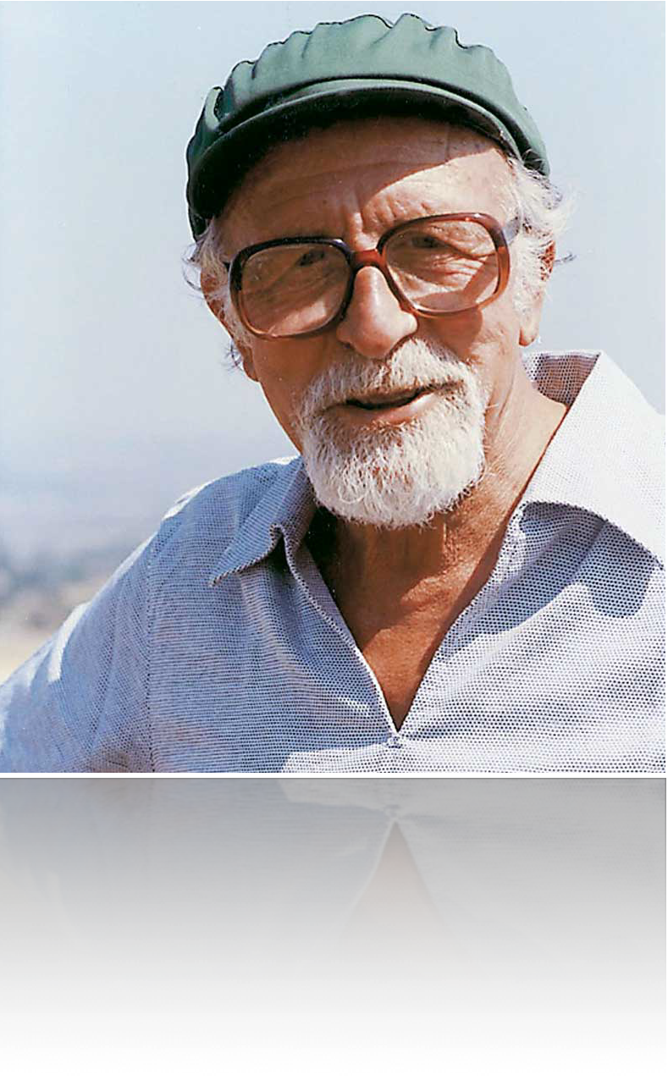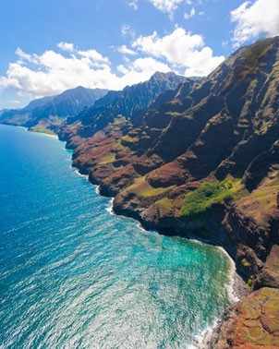

1lyk-peir-thess.thess.sch.gr

30, Kleanthous str

Tel. +30 2310 908700

Thessaloniki-Greece Chateau Thierry- France Karlovac- Croatia Kamenz- Germany

P ROG R A M OF TH E M E E TI N G

The activities on Tuesday, Wednesday and Thursday start at 8.15 am and will take place at the school. Details for outdoor activities of Monday and Friday are mentioned on the analytical

program. Hosted students have to be at school every day at 8.15 am .

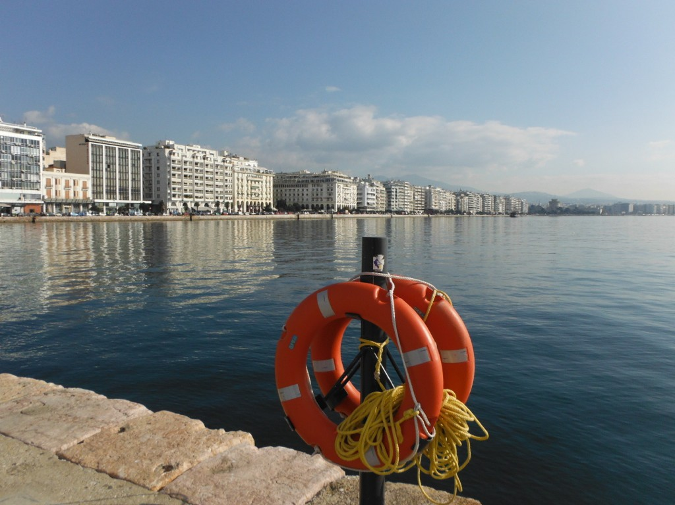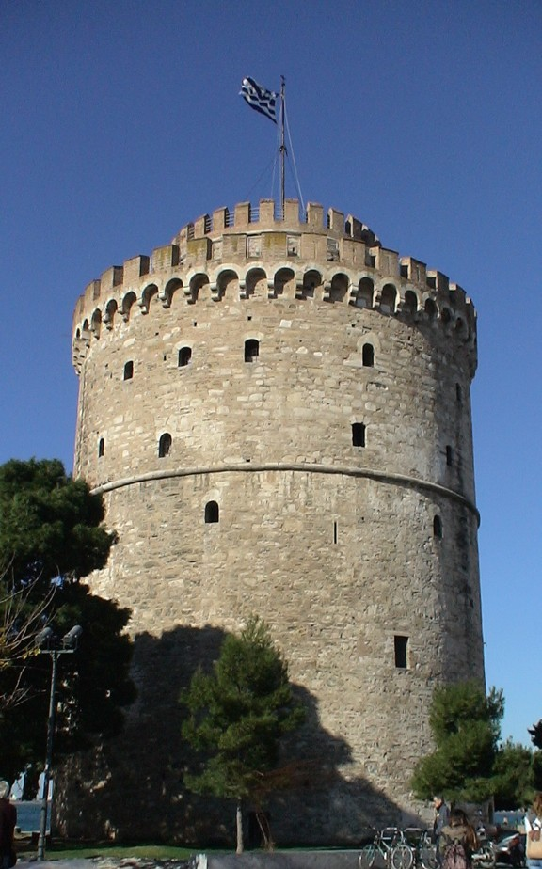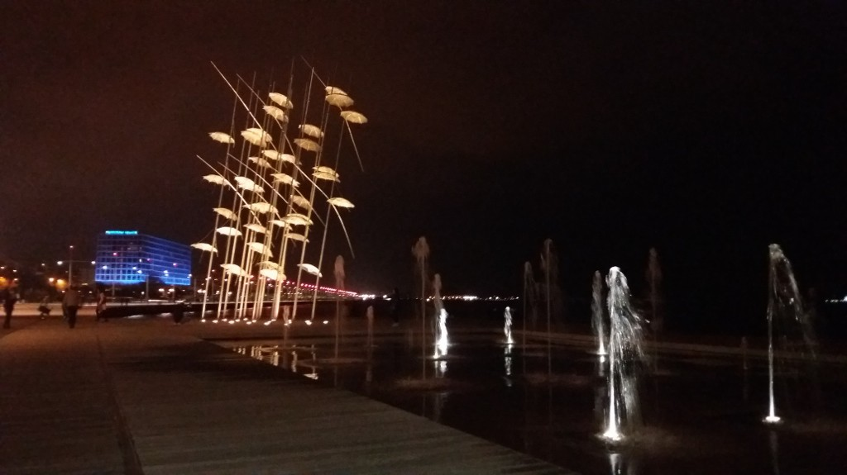

***Welcome to Thessaloniki***

USEFUL INFORMATION

Police: 100

First aid: 166

Thessaloniki airport:+30 2310 985000

Taxi: +30 2310 550500, +30 2310214900

Croatian consulate:+30 2310548203

German consulate: +30 2310 251126

French consulate: +30 2310 244030/031

MONDAY 1 1 /1 2 /2 01 7

8.15-9.00 Welcome activities at school

9.05-10.00 Presentations of the cities/towns of all schools

(10 min for each team)

10.15-11.30 Presentations of good practices . 10-15 min

11.30-12.00 Sort break/ departure

12.30-14.oo Guided tour in the White Tower/ light meal

14.30-16.30 Thematic guided tour. “Thessaloniki: a home for refugees.”

TUESDAY 12/12/2017

8.15-15.00 Intercultural training

(coffee/tea/juice/breaks, light meal included)

17.00-19.00 Coordinator’s meeting regarding the

2nd Project meeting

WE DN E SDAY 13/12/2017

8.15-15.00 Intercultural training

(coffee/tea/juice/breaks, light meal included)

18.00-20.00 Teachers visit the GNO “ARSIS”. Information about refugees in Greece

20.oo Diner for teachers, offered by hosting school

THURSDAY 14/12/2017

8.15-15.00 Intercultural training

(coffee/tea/juice/breaks, light meal included)

20.00-23.00 Farewell party at school, offered by the association of parents and hosting families.

FRIDAY 15/12/2017

8.15 Departure for daily trip to Vergina & Veroia

10.00-11.00 Guided tour to Archaeological

Museum of Vergina

12.00-15.30 Visit to Veroia. Lunch

15.30-17.00 Return to Thessaloniki

SATURDAY 16/12/2017

Departures